# SPS Problem Statement

Suppose you are working as a business analyst at Smart Consultants Pvt. Ltd. You work in the Data Science department, and there are other operations departments as well, such as Product Management, Supply Chain Management, Marketing, in the organisation. Your team receives a report from one of your clients seeking the team’s help with the problem that it is facing. The client runs an open-pit mine in the state and looks after the production of the desired composition of the ores extracted from the mine.

# What is Open-Pit Mining

Open-pit mining is a surface mining technique of extracting rocks or minerals from open-pit in the ground also known as a quarry. In the upcoming section, you will learn about open-pit mining.

Open-pit mining differs from extractive methods that require tunnelling into the earth, such as underground mining. Open-pit mines are used when deposits are found near the surface and surface material covering valuable deposits is thin or the material of interest is structurally unsuitable for tunnelling (as would be the case for sand, cinder, and gravel). Materials that can be extracted by this technique include bitumen, clay, coal, copper, coquina, diamonds, gravel and stone (stone refers to bedrock, whereas gravel is unconsolidated material), granite, gritstone, gypsum, limestone, marble, metal ores, such as copper, iron, gold, silver, and molybdenum, uranium and phosphate.

Besides the materials themselves, open-pit mining offers several benefits over the technique of deep-shaft mining. These include the following:

1. Ease of use for mass production
2. Low shut-down expense
3. Ability to mine selectively for certain grades of ore
4. Comparatively small crew size
5. Elimination of safety hazards that are associated with complex underground mining operations
6. Easy drainage of subsurface water
7. No machinery restrictions – even heavy and bulky machinery can be utilised

Nevertheless, these mining techniques have an environmental impact because of the dust particles and the noise created by the machinery, in addition to the large amounts of wasted rock being mined, which is quite common in mining processes.

# Open-Pit Mining Process

The open-pit mining process has set procedures. In the upcoming video, you will listen to Ved as he explains this process. Understanding this process is very crucial to solve the subsequent project as a supply chain problem.

A mining process consists of five steps, which include:

1. Drilling,
2. Blasting,
3. Excavation and digging,
4. Transportation and
5. Crushing.

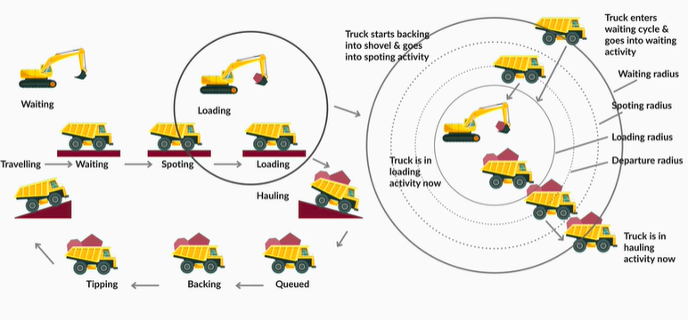As Gautam explained in the video, for a mining process to be efficient, there needs to be coordination between all of these steps. So, in the next segment, you will learn how this process can be made efficient.

# Mining in Supply Chain Domian

As you have seen in the last segment, coordination and planning are required for efficiency. So let’s go ahead and watch the upcoming video, which discusses how the open-pit mining process can be perceived as a supply chain problem and solve for better efficiency.

So, as Gautam explained in the video, for a mining process to be efficient, there needs to be coordination between three main processes: digging, transportation and crushing, where digger sites act as the Supplier and crusher sites act as the Demand centre. Hence, for seamless operation, we need an efficient network design.

We will summarise what we have learnt in this session in the next segment and in the next session, you will understand in detail the problem statement of your project.

# Summary

In this session on the business scenario on the open-pit mining, you understood the following terminologies

* Diggers
* Crushers
* Trucks

You also understood the processes in an open-pit mine. You will more details on your project in the upcoming session where you will get a detailed understanding of the project.

As a business analyst, your first task would be to understand the problem faced by the client. And to do that, you would want to understand the operational entities that are involved in the open-pit mine.

You realise that the following operational entities are associated with your client’s open-pit mine.

Digger: A digger is an operational tool that extracts the right proportion of the desired raw ore from holes that are blasted over a particular part of an open-pit mine.

Digger-to-Crusher Trucks: These are the empty trucks that are present at every digger. They get loaded with the raw ore that is extracted by the digger and make their way to the crusher as soon as they are loaded to their full capacity.

Crusher: The loaded trucks that have arrived all the way from the digger dump all the raw ore into the crusher, which is another operational tool present at multiple locations on an open-pit mine. The crusher crushes/processes the desired quality of ore composition required by the customers/clients of the open-pit mine.

Crusher-to-Digger Trucks: After dumping the raw ore into their allocated crushers, the digger-to-crusher trucks, which are now empty again, head back to the diggers to get loaded with raw ore.

Logistics Manager: The logistics manager acts as a medium between the customer and the open-pit mine. Customers reach out to the logistics manager before placing an order of a desired quantity and composition of a required ore. The final processed ore is also delivered to the customer via the logistics manager.

Customer: This is the end-user who had submitted the requirements with the logistics manager for the desired composition of ore to be processed.

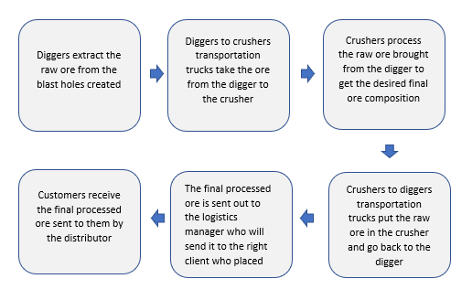So, you have now understood the operational entities associated with the open-pit mine. Now, even before you start understanding the problem faced by your client, you decide to use a 5W’s + How analysis to understand the inner workings and get more details on each of the entities.

So, what are the different kinds of questions that you would ask in order to understand some of the details on each of the six entities using the following interrogation?

1. What
2. How
3. When
4. Where
5. Which
6. Who

Observe the table given below. You will find certain sample questions for each of the operational entities. Replace the questions with blanks ‘----?’, writing suitable questions that you would ask for each particular operational entity.

Now, let’s assume that you have understood the operational entities of the open-pit mine after conducting the 5W’s + How analysis on the above table. Having understood all the mine operations, you realise that the problem that the company is facing is its inability to produce the optimum ore quantity that it is capable of producing in a day’s production effort. This in turn causes distrust among the customers since the mine is not able to send them the requirements on time.

Also, upon analysing the different factors associated with the operational entities, you realise that the mine is already equipped with the maximum capacity of diggers, crushers and trucks. This means that the actual production target for one day is what the mine is capable of achieving. Also, all the pieces of equipment present at the mine are operational and well-maintained.

We will look at the conversation with the operations manager at the open-pit mine.

To understand the conversation in great detail, we are attaching the text file of the conversation again below.

We are also attaching the dataset that the field operations manager gave to the analyst (i.e. you!).

Now, you need to briefly analyse the data set shared by the Field Operations Manager and also understand the conversation in detail shared in the above files. Then download the Excel file below where you need to write the answers or the reasons for the WHY questions just like an issue tree framework used for WHY analysis.

You will find empty boxes below each Why question. Those are issue tree charts. Write the reason for each Why question. A sample reason is filled for the first question in Excel. Fill in the missing reasons yellow boxes for the WHYs asked in the sheet.